EXERCISE 16
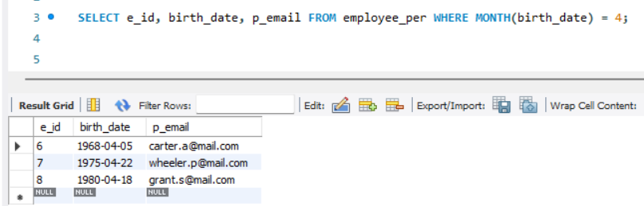
- List ids, birth dates and emails of employees born in April.

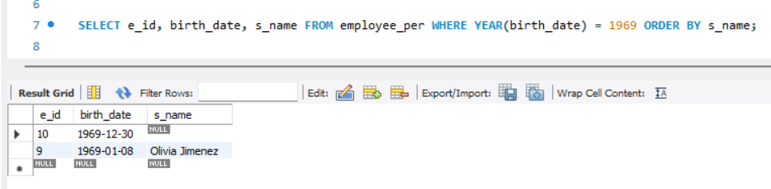
- Display Ids, birth dates and spouse names of employees born in 1969 and sort the entries on the basis of their spouse names.

- List the employee ids for employees born under the current month.
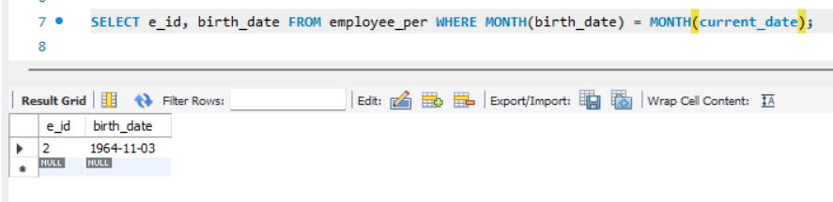

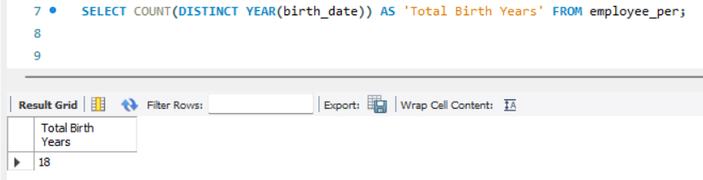
- How many birth years do we have?

- Display a list of unique birth years and the number of employees born under each.
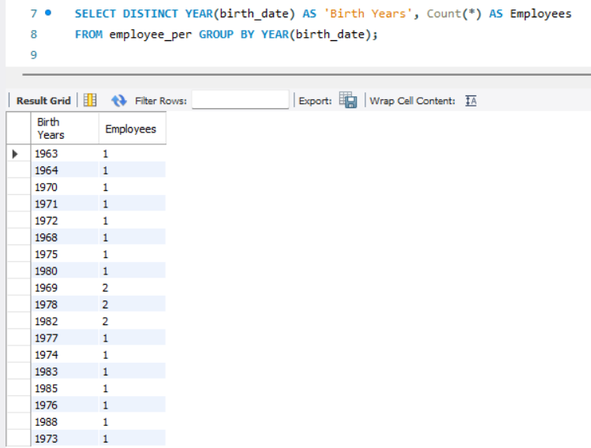

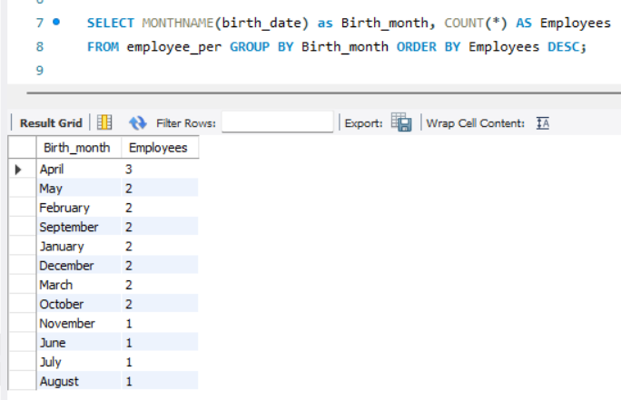
- How many employees were born under each month? The display should have month names (NOT numbers) and the entries should be sorted with the month having the largest number listed first.

